**LAB 4A**

1. USER table:

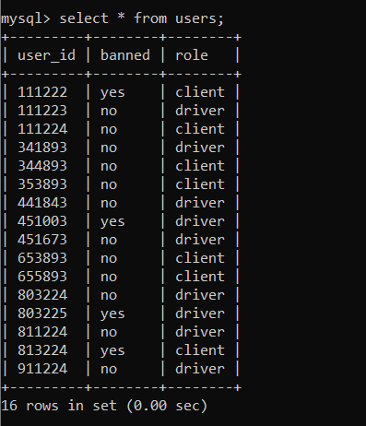

1. TRIPS table:

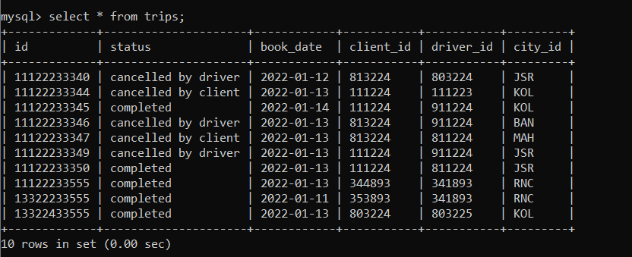

1. Table displaying the banned status of drivers

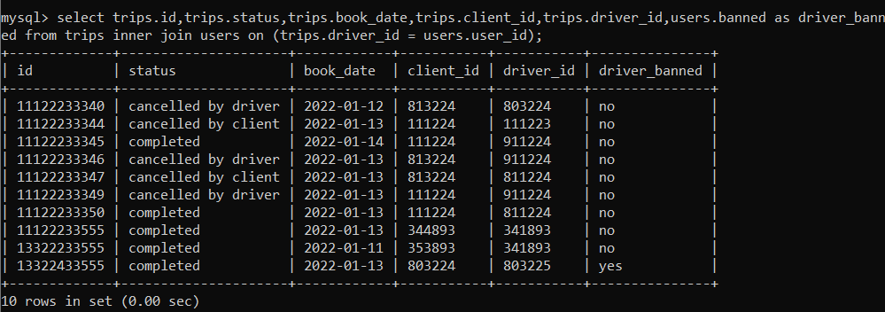

1. Table displaying the banned status of drivers and clients in one table

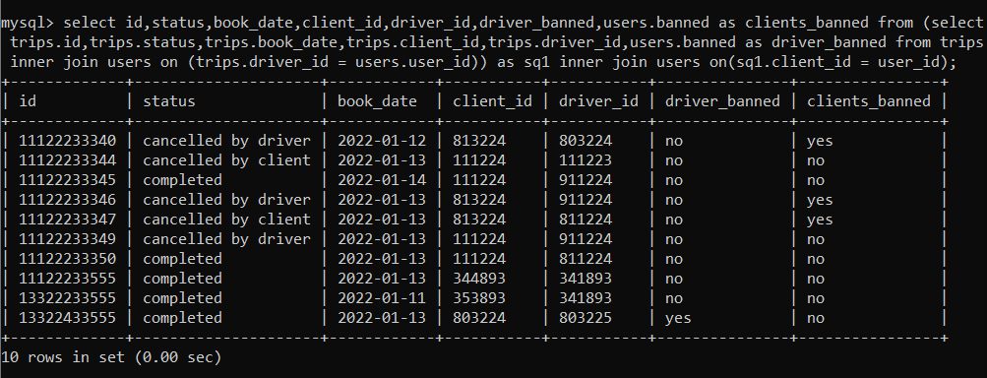

1. Table displays trips made on the 13th Jan 2022, considering clients and drivers are unbanned.

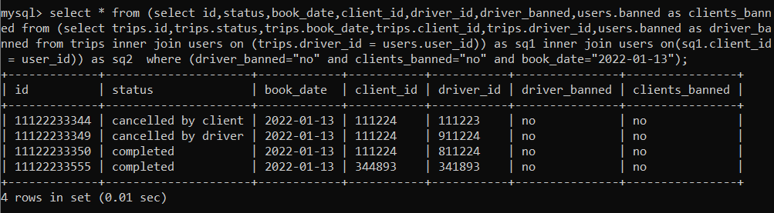

1. Finding the rate of cancellation based on the table above.

